|  |  |
| --- | --- |
|  | **MINISTRY OF EDUCATION AND TRAINING** |

**FPT UNIVERSITY**

|  |
| --- |
| Capstone Project Document |
| PET DATING |
| **VERSION 1.0** |
| |  |  | | --- | --- | |  | | | **Supervisor** | **Phan Duy Hùng** | | **Group Members** | **Nguyễn Đức Thịnh – SE06149**  **Nguyễn Đỗ Anh Khương – SE05608**  **Khương Trung Hiếu– SE06020**  **Trịnh Văn Anh – SE05308**  **Nguyễn Hoàng Phong – SE05668** | | **Capstone Project code** | **PD** | |
|  |

Ha Noi, May 31, 2020

Contents

CHAPTER 1: INTRODUCTION 4

1.1. Propose 4

1.2. Project Information 4

1.3. The People 4

1.4. Background 5

1.5. The Problem 5

1.6. Literature Review 5

1.1. The Proposal 5

1.1.1. The idea 5

1.1.2. The proposal 6

# 

# CHAPTER 1: INTRODUCTION

## Propose

This chapter provides an overview of the capstone project. It includes the project information, the background of the capstone project, the problem and our proposal to solve the problem.

## Project Information

|  |  |
| --- | --- |
| Project Information | |
| Project name | Pet Dating |
| Project code |  |
| Group name |  |
| Product type | Mobile Application |
| Timeline |  |

## The People

Supervisor:

|  |  |  |  |
| --- | --- | --- | --- |
| Full name | Phone | E-Mail | Title |
| Phan Duy Hùng |  | HungPD2@fe.edu.vn | Supervisor |

Team members:

|  |  |  |  |  |
| --- | --- | --- | --- | --- |
| Full name | Student ID | Phone | E-Mail | Title |
| Nguyễn Đức Thịnh | SE06149 | 0359629846 | Thinhndse06149@fpt.edu.vn | Leader |
| Nguyễn Đỗ Anh Khương |  |  | @fpt.edu.vn | Member |
| Khương Trung Hiếu |  |  | @fpt.edu.vn | Member |
| Trịnh Văn Anh |  |  | @fpt.edu.vn | Member |
| Nguyễn Hoàng Phong |  |  | @fpt.edu.vn | Member |

## Background

Nowadays, people are always busy and rarely have time for their relationship. So, a lot of people choose a pet to be a companion. According to the Q&ME survey, 49,9% of people own a dog or a cat for this purpose. The spent time for these little friends at least 4 years in their life. Obviously, having pets in house is not only for guarding or catching mice. Pets now are treated as family members by their owner.

## The Problem

Most of people who own pets always care about life of their pets such as food, morale and mates. However, the network where puppies can find a friend or partner is very rare in Viet Nam. Facebook – a social network that is popular had a lot of groups about this problem. But in there, we also lack of specific features that focus in users that have pets. Some other communities are not really popular or have stopped working. In conclusion, there are not really any online place or community for people that have pets in Vietnam right now.

## Literature Review

We consulted some websites/application about pet before give our proposal. Each website/application has a lot of advantages but still has some limitations.

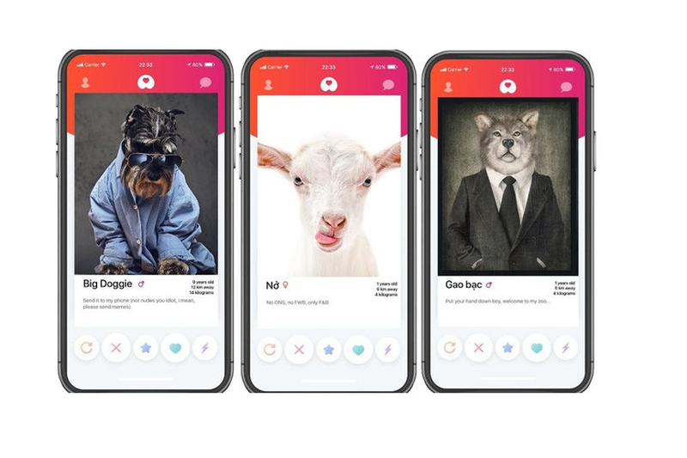

Get bone (app)

Advantages and Disadvantages of Get bone

|  |  |
| --- | --- |
| **Advantages** | **Disadvantages** |
| * Provide news and more information about pets. * Interface is easy to use and be like Tinder * Support finding mates. | * Only news, no communication between users |

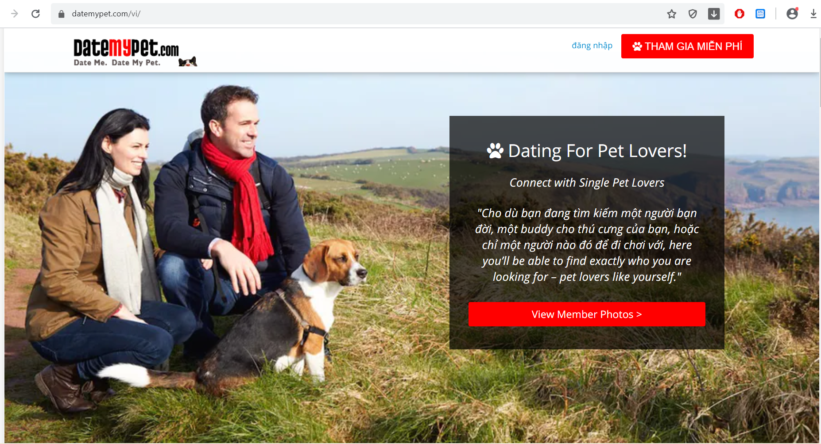

Datemypet.com

|  |  |
| --- | --- |
| **Advantages** | **Disadvantages** |
| * Provide news and more information about pets. | * Not support finding mates. * Only news, no communication between users |

## The Proposal

### The idea

We want to build a mobile application where everyone can find the half of their pets, or simply want to know about other pets. Major of application is finding the mates for their pets based on automation mode or manual mode. In the app, people maybe complete the user’s profile; pet’s profile; upload images; match what pets they want. In addition, everyone can connect and chat about pets. It helps making pets dating becomes easy, safe and enhance the community. Our idea has two part: mobile application for user and website for manager.

### The proposal

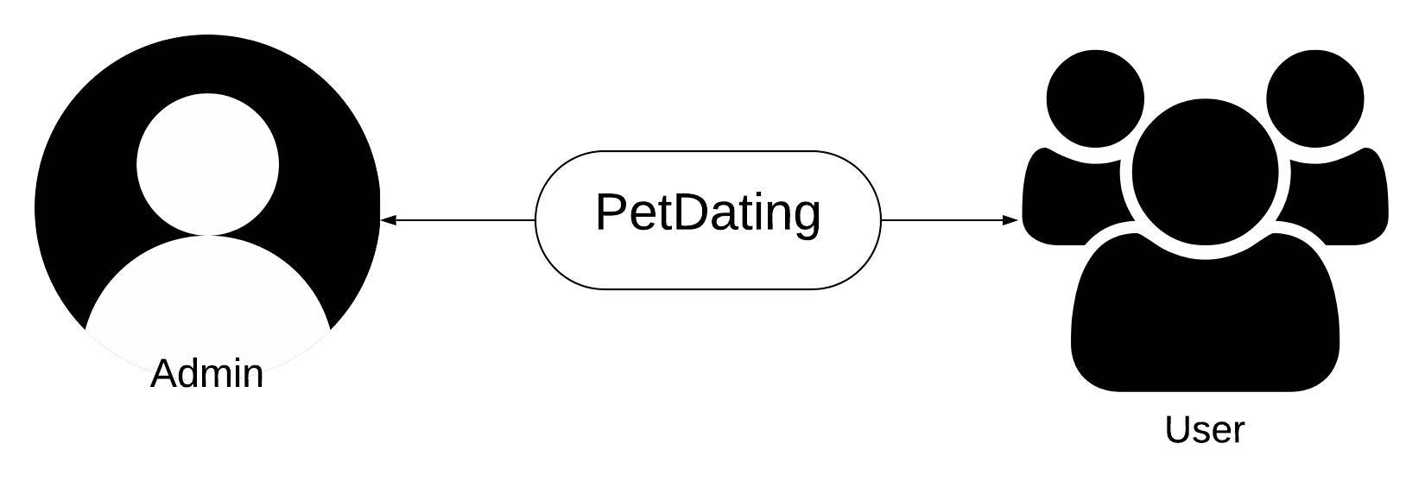

Figure 3 - Roles in PD system

### System functions

There are three roles and responsibilities of each role on PetDating:

|  |  |
| --- | --- |
| **Role** | **Responsibilities** |
| Admin | Somebody who manage the PD system. |
| Users | People who join and use PD application |

The system has the following roles and main functions:

* Admin:

+ Login and Logout to website.

+ Review reports from user.

+ Ban and Unban user.

* Users

+ Login and Logout to mobile application.

+ View user profile and modify your profile.

+ Create, modify your pet profile and view the pet profile. The pet profile defines the name, sex, age, … of pets.

+ Upload images and set privacy such as private or public.

+ Users can use dating function to find mates for pets. There are two types of finding mates:

* + Find mates by automation: Application suggests pets base on your nearly location and all of pets in your profile.
  + Find mates by manual: Application suggests pets base on your choosing.

+ Users can use chatting system to connect to other users.

+ Feedback about system.

+ Report other account.

### Business flow

* **Review report process**

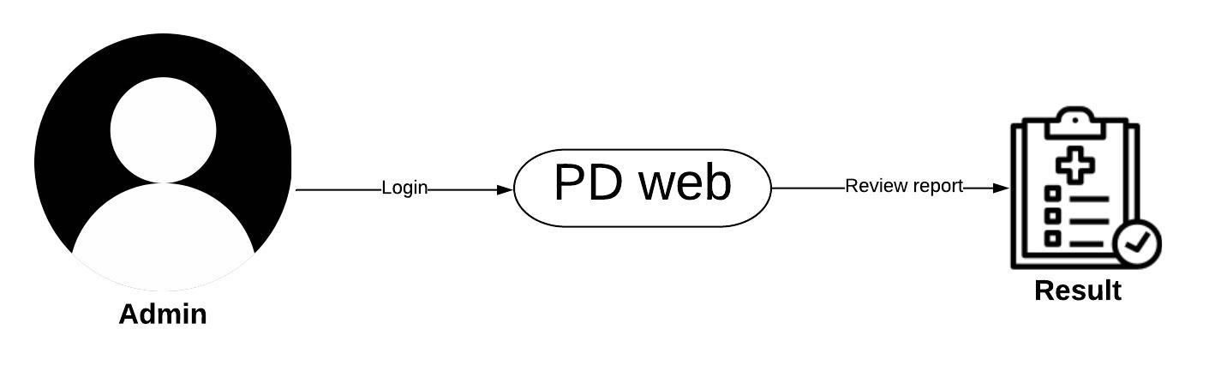

Figure 5 - Process of review report on PD

* **Ban and unban user**

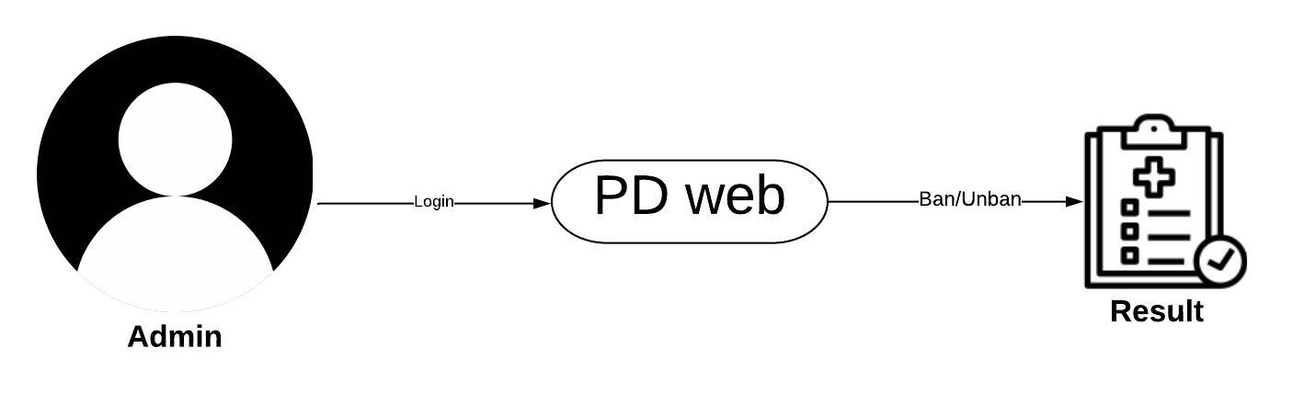

Figure 6 - Process of ban/unban on PD

* **Dating process**

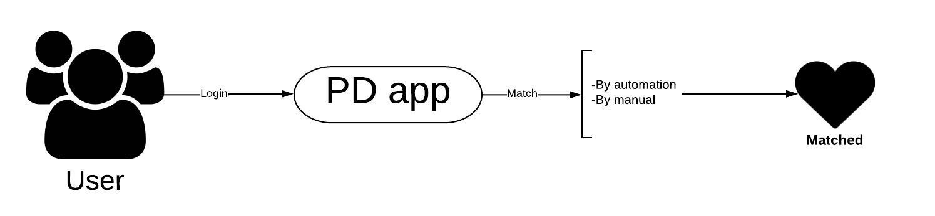

Figure 6 - Process of Dating on PD

* **User management process**

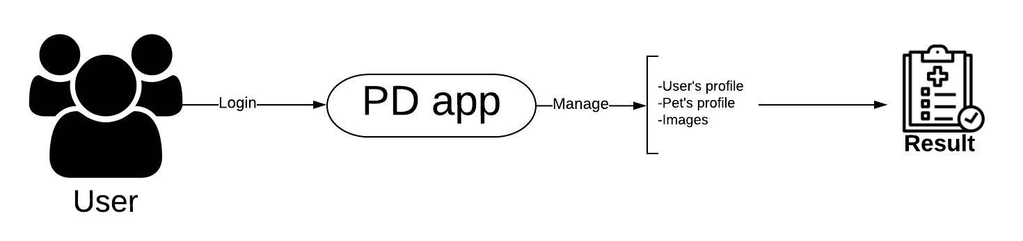

# **CHAPTER 2: SOFTWRE PROJECT MANAGEMENT PLAN (SPMP)**

## 2.1. Purpose

Project plan describes the software process model, team organization and management plan of the project. All team members must follow this section as a guideline to complete assigned tasks and deadline.

## 2.2. Software Process Model

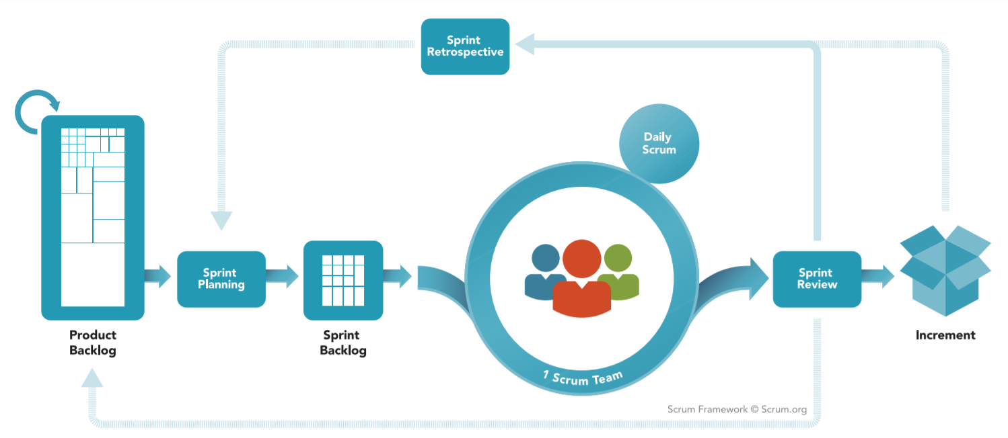

### 2.2.1. About the SCRUM

SCRUM is Agile software development life cycle (SDLC) models. Scrum is a framework within which people can address complex adaptive problems, while productively and creatively delivering products of the highest possible value. And it is a simple framework for effective team collaboration on complex products.

* **Product Backlog**: is an ordered list of everything that is known to be needed in the product. It is the single source of requirements for any changes to be made to the product.
* **Sprint Planning**: The work to be performed in the Sprint is planned at the Sprint Planning. This plan is created by the collaborative work of the entire Scrum Team.
* **Sprint Backlog**: is the set of Product Backlog items selected for the Sprint, plus a plan for delivering the product Increment and realizing the Sprint Goal. The Sprint Backlog is a forecast by the Development Team about what functionality will be in the next Increment and the work needed to deliver that functionality into a “Done” Increment.
* **Sprint**: The heart of Scrum is a Sprint, a time-box of one month or less during which a “Done”, useable, and potentially releasable product Increment is created. Sprints have consistent durations throughout a development effort. A new Sprint starts immediately after the conclusion of the previous Sprint.

*Reference: “The Scrum Guide - The Definitive Guide to Scrum: The Rules of the Game” – Developed and sustained by Scrum creator: Ken Schwaber and Jeff Sutherland – November 2017.*

### 2.2.2. Advantages and disadvantages of SCRUM

|  |  |
| --- | --- |
| **Advantages** | **Disadvantages** |
| * Works well for fast-moving development projects. * The team gets clear visibility through scrum meetings. * Removing mistakes or rectifying them is considerably easy. * It is iterative in nature and needs continuous feedback from the user for the betterment of the process. | * Scrum often leads to scope creep, due to the lack of a definite end-date. * The chances of project failure are high if individuals aren't very committed or cooperative. * If any team member leaves in the middle of a project, it can have a huge negative impact on the project. * Daily meetings sometimes frustrate team members |

Table 1 - Advantages and disadvantages of SCRUM

## 2.3. Project Organization

### 2.3.1. Organization structure

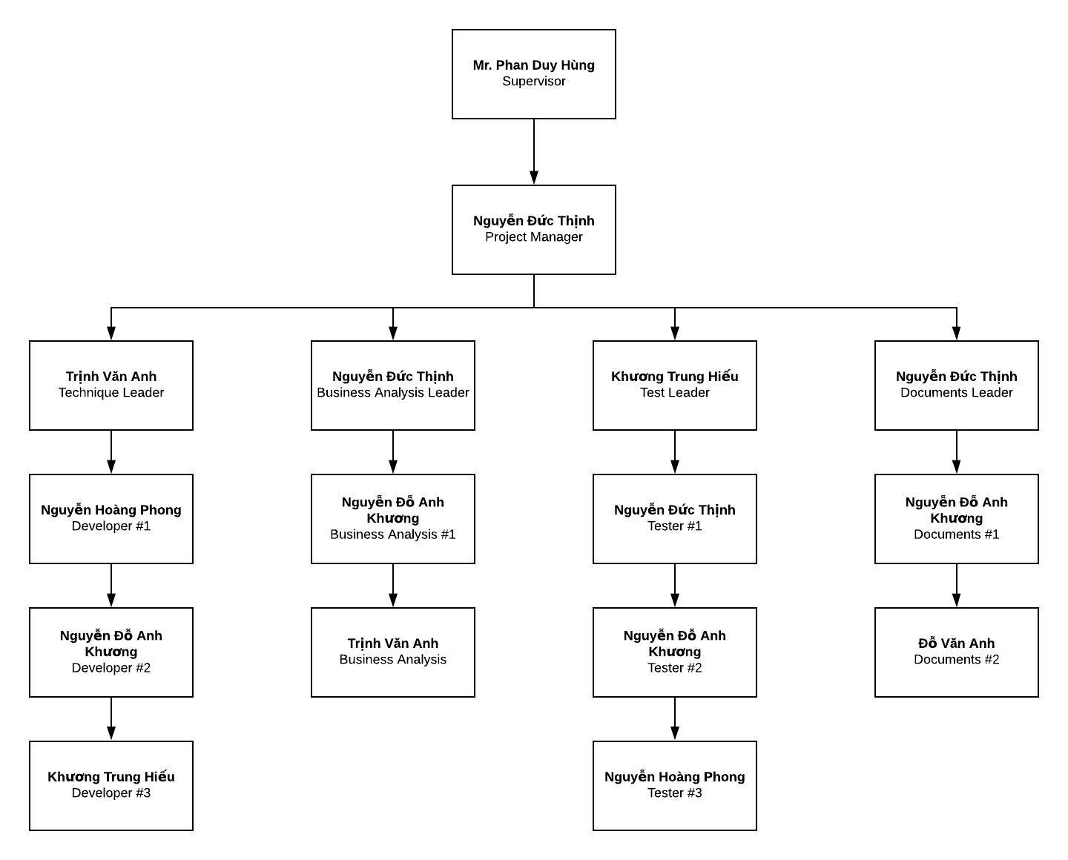

Figure 9 - Organization structure

### 2.3.2. Roles and responsibilities

|  |  |  |
| --- | --- | --- |
| **Role** | **Responsibilities** | **Full Name** |
| **Project Manager** | | |
| Project Manager | * Guide team toward the goal of successfully passing the final capstone project. * Develop schedule and assigning task with responsibilities for each member. * Communicate with all teams to keep them focusing on the final goal. * Propose ideas or issues of the team to supervisor, university. | Nguyễn Đức Thịnh |
| **Business analyst team** | | |
| BA leader | * Elicit and analyze requirement. * Define scope and create SRS template. | Nguyễn Đức Thịnh |
| BA #1 | * Design entity relationship diagram. * Define business process flow and object state. | Nguyễn Đỗ Anh Khương |
| BA #2 | * Capture and specific describe use case. | Trịnh Văn Anh |
| **Developer** | | |
| Technical leader | * Define high level architecture base on SRS. * Implement configuration and server. * Design and code dating function. * Develop client functions in console system. * Design and review database. * Design mockup for application. | Trinh Văn Anh |
| Dev #1 | * Lead chatting function. * Design a part of database. * Design and code chatting function. * Code others screen. * Design mockup for application. | Nguyễn Hoàng Phong |
| Dev #2 | * Design and code dating function. * Code others screen. * Design mockup for application. | Nguyễn Đỗ Anh Khương |
| Dev #3 | * Design and code chatting function. * Code others screen. * Design mockup for application. | Khương Trung Hiếu |
| **Tester** | | |
| Test leader | * Create template testing documents. * Define test strategy, create test plan and defect log temple. | Khương Trung Hiếu |
| Test #1 | * Implement test case and log defect. | Nguyễn Đức Thịnh |
| Test #2 | * Implement test case and log defect. | Nguyễn Đỗ Anh Khương |
| Test #3 | * Implement test case and log defect. | Nguyễn Hoàng Phong |
| **Documentation** | | |
| Docs leader | * Prepare all the documentation relating to the project. * Give format in documentation. | Nguyễn Đức Thịnh |
| Docs #1 | * Check spelling errors and grammar errors. | Nguyễn Đỗ Anh Khương |
| Docs #2 | * Check spelling errors and grammar errors. | Đỗ Văn Anh |

Table 2 - Roles and responsibilities

## 2.4. Tools and Techniques

## 2.5. Project Management Plan

### 2.5.1. Project schedule

The tasks list detail is described in file: **“Plan.mpp”**

### 2.5.2. Meeting minutes

### 2.5.3. Risk management plan

### 2.5.4. Communication plan

### 2.5.5. Coding convention